FLAMBOROUGH WOMEN’S INSTITUTE

The W I has been part of Flamborough village since 1941. At first the meetings were held in the Methodist rooms, then, after WWII, thanks to the generosity of Tom Waines making a Nissen hut available and the Fell family providing the land on which to site it, the WI had their own hall.

Over the years the WI members worked hard to make the hall comfortable and keep it weatherproof. During the Millennium year the decision was made to make the building more user friendly, so in 2005 after much fund-raising and grant applications, we had built a brick skin and new roof, committee/store room, new toilets including one for disabled people and a ramp for easier access.
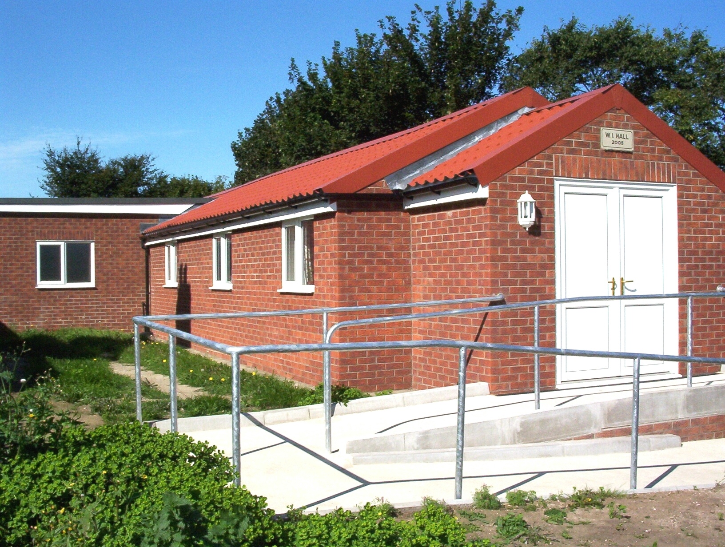

As well as W I meetings and activities the hall is used by Pre School, and is available for hire, by other groups and organisations at £9.00 per hour, including use of kitchen facilities.

W I members also cater for parties wanting lunches & afternoon teas, when they visit Flamborough and the Heritage Coast – “from a car load to a coach load” (max 40)

Lunches, £8.00 per person
Afternoon teas, £6.00 per person
Our teapots never run dry – try us!

New members are always welcome and visitors can attend a few meetings before deciding whether or not to join.
Come and join Arts/Crafts each Monday morning 10 to 12am - then Table Tennis and/or Board Games from 2 to 4pm - refreshments served. Men are welcome to join in the activities for just £1 donation.
Members meetings with a varied programme are held on the third Tuesday of each month in the W I hall overlooking the Green and they begin at 7 pm.
Refreshments and homemade cakes at every meeting

For more information contact - Margot Maxwell on 07527044552

